Carbon Monoxide | CPSC.gov (Dec 2022)
www.cpsc.gov/Safety-Education/Safety-Education-Centers/Carbon-Monoxide-Information-Center
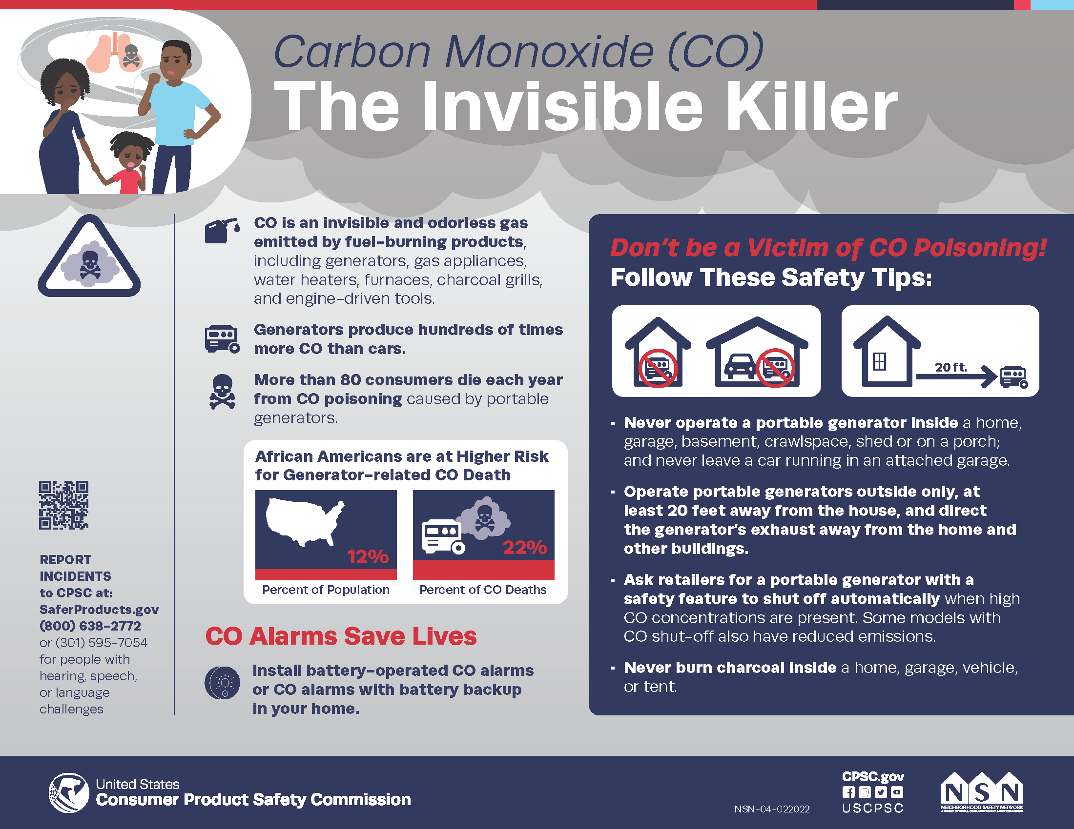

Carbon monoxide, also known as CO, is called the "Invisible Killer" because it's a colorless, odorless, poisonous gas. More than 150 people in the United States die every year from accidental non-fire related CO poisoning associated with consumer products, including generators. Other products include faulty, improperly-used or incorrectly-vented fuel-burning appliances such as furnaces, stoves, water heaters and fireplaces.

Safety Tips
- Have your home heating systems (including chimneys and vents) inspected and serviced annually by a trained service technician.
- Never use portable generators inside homes or garages, even if doors and windows are open. Use generators outside only, far away from the home.
- Never bring a charcoal grill into the house for heating or cooking. Do not barbeque in the garage.
- Never use a gas range or oven for heating.
- Open the fireplace damper before lighting a fire and keep it open until the ashes are cool. An open damper may help prevent build-up of poisonous gases inside the home.
- Install battery-operated CO alarms or CO alarms with battery backup on every level of the home and outside sleeping areas. Interconnected CO alarms are best; when one sounds, they all sound.
- Know the symptoms of carbon monoxide poisoning: headache, dizziness, weakness, nausea, vomiting, sleepiness, and confusion. If you suspect CO poisoning, get outside to fresh air immediately, and then call 911.

